Name : Shriya Ramya Mohan
Roll No : 241901106 EXP NO: 6

BUILDING AN ANONYMOUS FTP SCANNER USING FTPLIB MODULE

AIM
To build a simple anonymous FTP scanner in Python (using ftplib) that attempts an anonymous login to a target FTP server and, if successful, displays the welcome message and lists the root directory.
INTRODUCTION
FTP servers sometimes allow anonymous access using the username anonymous (any email/password). Using Python’s built-in ftplib, we can programmatically test whether a host permits such access. This is useful for audits and learning about authentication defaults.
ALGORITHM
1. Import library: import ftplib.
2. Define function anonymousLogin(hostname):
- Try:
  - Create FTP client: ftp = ftplib.FTP(hostname).
  - Attempt login with username="anonymous", password="anonymous".
  - Print the server’s login response string.
  - If the response contains "230 Anonymous access granted":
    - Print success message with hostname.
    - Print server welcome text: ftp.getwelcome().
    - List directory contents: ftp.dir().

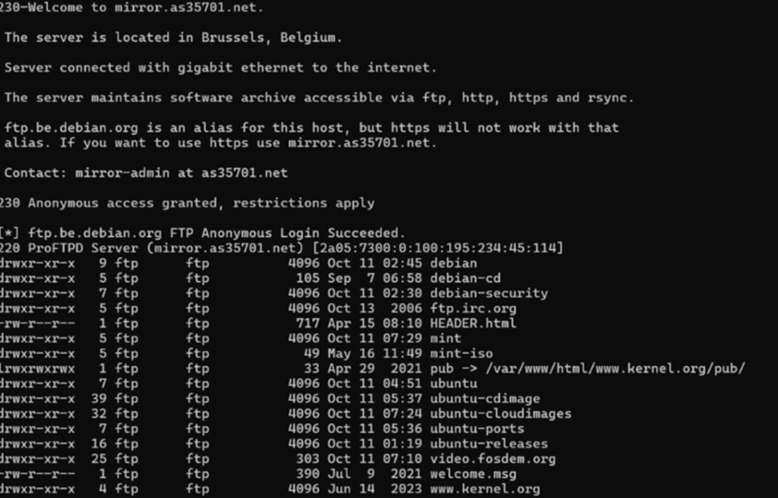

RESULT:
A simple anonymous FTB scanner in python using ftblib is successfully built and executed.

